**Report for RT Graphics Portfolio Critique**

I had the owner of the club we play at do the first critique. Since he is a business owner, I figured he would be the hardest on the site. He actually liked it.

My husband, Will Diamond gave the other critique. He was a little more picky about the site. He noticed that the image on the about page was not quite centered – I kind of expected that. I’m kind of surprised that he didn’t catch the asterisk on the name input of the form.

As a first pass, I am comfortable turning the site in as is. I will however fix the asterisk and the image before I use this as my official portfolio.

Critique from Matt Billings – Owner of Main Street Brewery

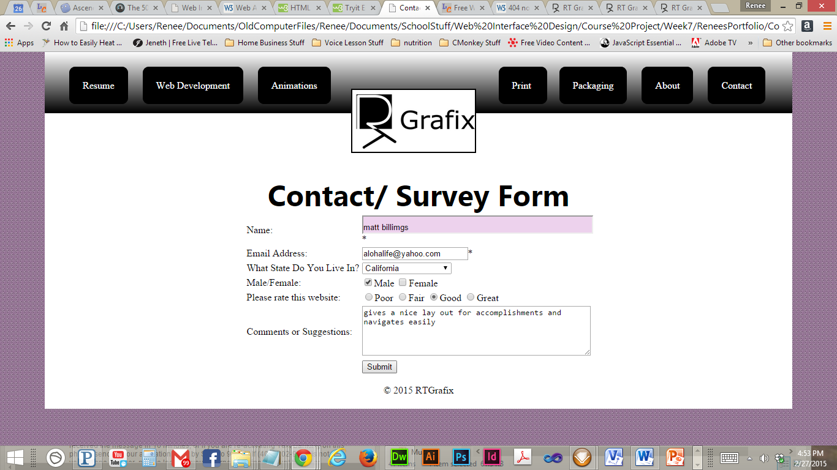

Critique from Will Diamond – My husband

